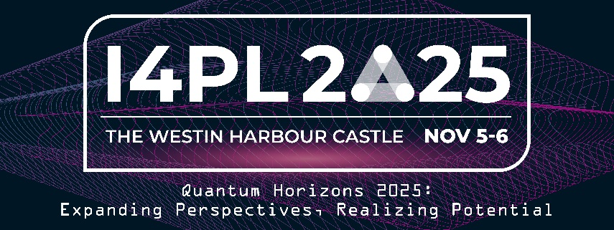

Dear [insert name]
I am reaching out to seek your approval for my attendance at The Annual I4PL Conference, scheduled to take place at the Westin Harbour Castle Hotel in Toronto from November 5-6, 2025. The conference theme, " Quantum Horizons 2025: Expanding Perspectives, Realizing Potential," aligns with the dynamic nature of our evolving work environment.
Having conducted thorough research, I have identified the I4PL 2025 Conference as a prime opportunity to acquire valuable insights, tools, and best practices in the rapidly changing field of learning and development. Where the evolving landscape of Performance and Learning converges with new possibilities. This year’s theme, “Expanding Perspectives, Realizing Potential,” draws inspiration from the transformative nature of quantum thinking—embracing complexity, adaptability, and interconnectedness.
Outlined below are key benefits that my participation in this conference will bring to our organization:
In-Person Experience: The conference offers a two-day, in-person experience featuring a distinguished lineup of industry experts and globally recognized keynote speakers. This provides an invaluable opportunity to gain insights from thought leaders at the forefront of organizational agility.
With a comprehensive selection of 32 insightful sessions and thought-provoking Leader Panels, and dynamic discussions, we will examine challenges, opportunities, and innovative practices that drive continuous learning and performance. The conference promises a wealth of knowledge directly applicable to the organization.
Networking Opportunities: The event will bring together hundreds of L&D professionals from various sectors nationwide. This presents a unique chance to network with peers, stay abreast of industry trends, potentially connect with mentors, and explore cutting-edge developments in the L&D field.
To provide further insight, you can view the agenda of the conference by clicking Here, the agenda shows the sessions available for me to attend with many that align with our organization's goals.
The cost for my attendance will be [insert cost]. You can review the event pricing by clicking Here. Please note that registration concludes on October 15th, 2025.
I firmly believe that my participation in this conference will enhance my ability to support our organization and employees in their learning journey. The knowledge gained and connections made will undoubtedly contribute to our success in the performance and learning domain.
Thank you for considering my request to attend the I4PL 2025 Conference.
Sincerely,
[Your Name]

