Exhibitor Shipping Instructions
ATA e-Business Forum and S1000D User Forum
- Kindly note that storage space at the hotel is limited.
- Boxes should not arrive too far in advance—delivery is permitted only up to three days before the event
- SHIPPING LABEL
Please use the shipping label (page 2) for parcels sent to the hotel.
- LOADING DOCK
Access to the hotel's loading dock is located on Fortifications Lane, between St-Antoine and Notre-Dame streets, accessible via St-Pierre Street. See Appendix II for a location map of the loading dock.
- FREIGHT ELEVATOR
The dimensions of the freight elevator are 18’7” in length, 7’8” in width, and 9’ in height. On the 8th floor, the freight elevator door provides easy access to the Grande Place, the exhibition hall.
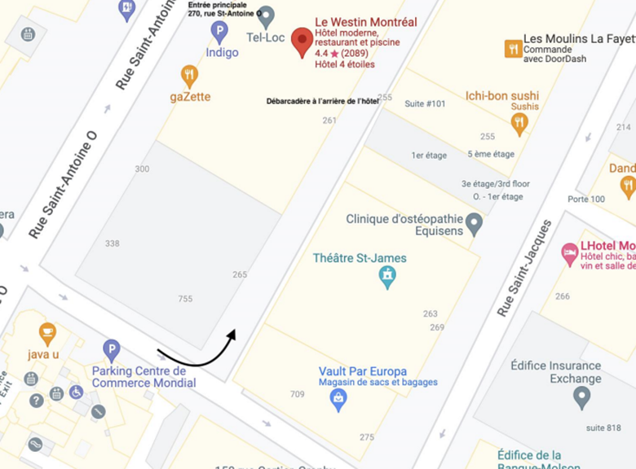
- HOTEL CONTACT
Krishnen Govindasawmy
Director of Convention and Banquet Services
LE WESTIN MONTRÉAL
kgovindasawmy@westinmontreal.com

Shipped From:
Company:
Address:
Phone: Fax:
Via Shipping Company:
Phone #:__________________________
Waybill #:_________________________

SHIP TO: Le Westin Montreal
270 St. Antoine West
Montréal, Québec H2Y 0A3
Canada
Attention: Krishnen Govindasawmy,
Director, Convention and Banquet Services

Conference Title: ATA eBusiness/S1000D Forum
Date of Conference: Oct 6-8, 2025
Exhibitor Name:
Box ______of ______(Total # of Boxes in Shipment)

